

Capstone Project Report
Report 4 – Software Design Document

– Ho Chi Minh, October 2024 –

Table of Contents
I. Record of Changes 4
II. Software Design Document 5
1. System Design 5
1.1 System Architecture 5
1.2 Front-End Package Diagram 6
1.3 Back-End Package Diagram 7
2. Database Design 8
2.1 Account Table: 9
2.2 AccountAddress Table: 10
2.3 AssetURL Table: 10
2.4 BranchMaterial Table: 10
2.5 BranchService Table: 11
2.6 BusinessBranch Table: 11
2.7 BusinessProfile Table: 11
2.8 BusinessStatistic Table: 12
2.9 Cart Table: 12
2.10 CartItem Table: 12
2.11 Feedback Table: 13
2.12 Leaderboard Table: 13
2.13 Material Table: 13
2.14 Order Table: 13
2.15 OrderDetail Table: 14
2.16 OrderNotification Table: 14
2.17 PackSubscription Table: 15
2.18 PlatformPack Table: 15
2.19 PlatformStatistic Table: 15
2.20 Promotion Table: 15
2.21 Service Table: 16
2.22 ServiceCategory Table: 16
2.23 ServiceProcess Table: 16
2.24 SupportTicket Table: 16
2.25 TicketCategory Table: 17
2.26 Transaction Table: 17
3. Detail Design 18
3.1 Create Service 18
3.2 Add To Cart 21
3.3 Create Material 24
3.4 Check out 27
3.5 Create Feedback 30
3.6 Register Business 33
3.7 Create Ticket 36
3.8 State Diagram 39
4. Ranking Algorithm 43
4.1 Theory and Practice: 43
4.2 Calculation Formula: 43

I. Record of Changes
Date | A*  M, D | In charge | Change Description
17/10/2024 | A | ThaoHTP | Add Front-End Package Diagram.
21/10/2024 | A | QuocLNH | Add System Architecture, Back-End Package Diagram.
22/10/2024 | A | NgocPD, QuocLNH | Add Database design.
30/11/2024 | M | QuocLNH | Update System Design, Database Design
30/11/2024 | A | HieuNM | Add Detail Design
12/11/2024 | M | QuocLNH,  HieuNM | Update Database Design
*A - Added M - Modified D - Deleted

II. Software Design Document

1. System Design

1.1 System Architecture
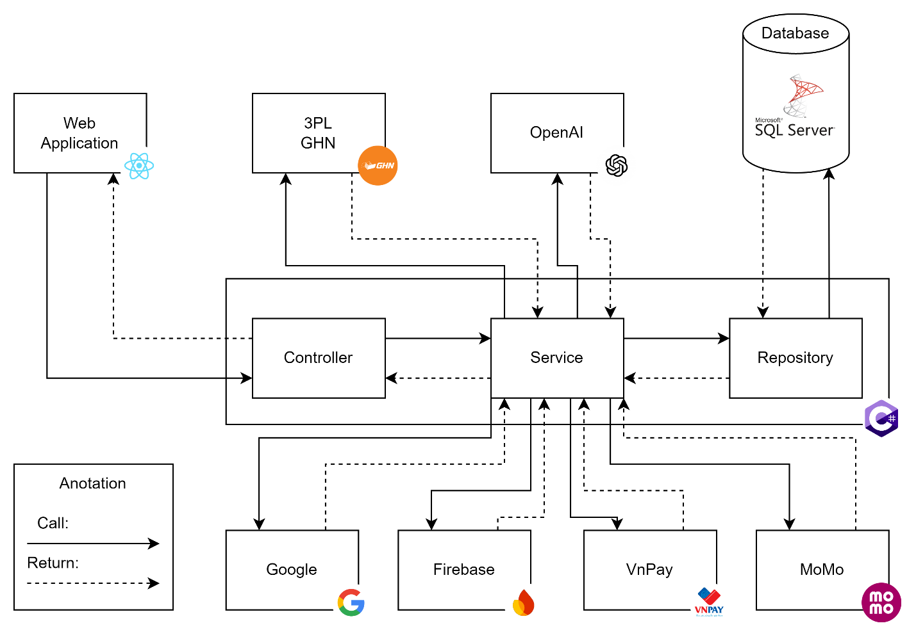

1.2 Front-End Package Diagram
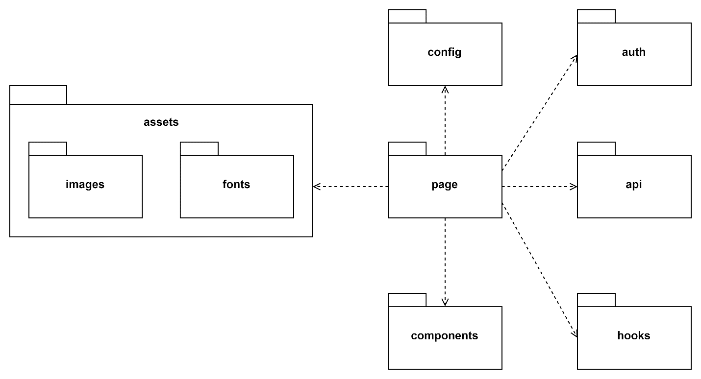
Package Descriptions
No | Package | Description
01 | page | Contains different pages of the application
02 | assets | Contains all static assets, such as fonts, images, icons, etc.
03 | components | Contains a collection of UI components for reusing such as buttons, modals, inputs, loaders, pages, etc.
04 | hooks | Contains reusable functions (hooks) that encapsulate specific logic (interacting with local storage, etc.)
05 | config | Contains configuration files for the whole application (Firebase, i18n, routing, etc.)
06 | api | Contains functions to perform API requests, handle authentication, manage errors, and other tasks
07 | auth | Contains components and logic related to user authentication, including login and registration, etc.

1.3 Back-End Package Diagram
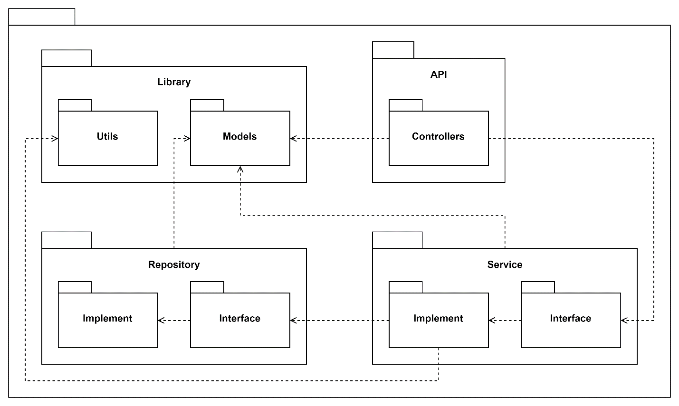
Package Descriptions
No | Package | Description
01 | Controllers | Contains API controller class of the system.
02 | Service Interface | Contains service interface of the system.
03 | Service Implement | Contains service interface’s implement class of the system.
04 | Repository Interface | Contains repository interface of the system.
05 | Repository Implement | Contains repository interface’s implement class of the system.
06 | Models | Contain model class of system such as: Data Model, Request Model, Response Model.
07 | Utils | Contains util class of system like: Mapper class, Util class, …

2. Database Design
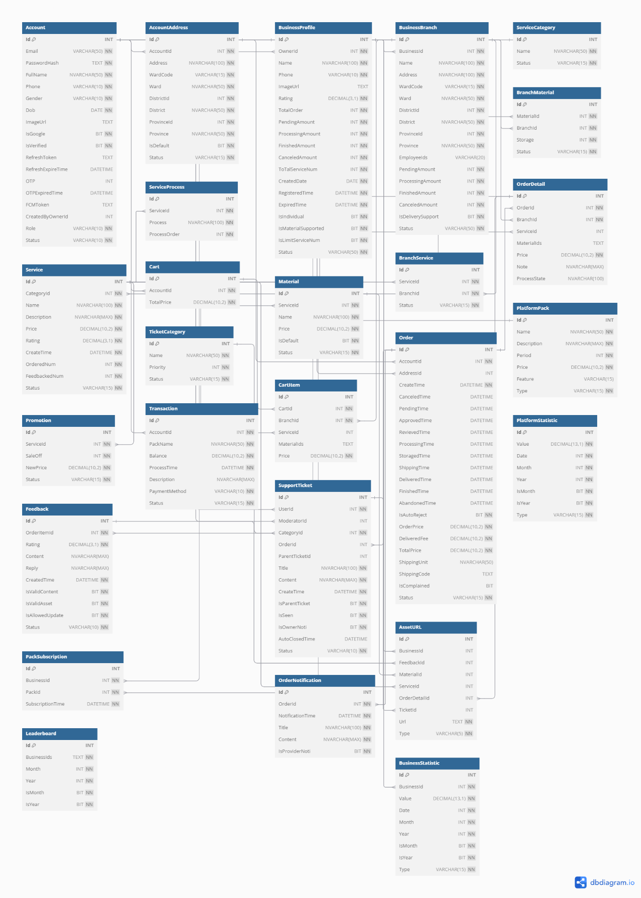
Table Descriptions
# | Entity | Description
01 | Account | Store user’s account information in platform
02 | AccountAddress | Store user’s address in platform
03 | AssetURL | Store image or video URL of BusinessProfile, Feedback and Service entities
04 | BranchMaterial | Store information of material has in branch
05 | BranchService | Store information of service has in branch
06 | BuisnessBranch | Store branch information of BusinessProfile entity
07 | BusinessProfile | Store business information in platform
08 | BusinessStatistic | Store business statistic information in platform
09 | Cart | Store account’s cart in platform
10 | CartItem | Store items have been added to Cart entity
11 | Feedback | Store service feedback of customer in platform
12 | Leaderboard | Store platform top 10 business ranking information
13 | Material | Store service require or addition material
14 | Order | Store order information in platform
15 | OrderDetail | Store order items of Order entity
16 | OrderNotification | Store order’s notification context in platform
17 | PackSubscription | Store business registered feature pack information
18 | PlatformPack | Store platform pack information: subscription pack and feature pack
19 | PlatformStatistic | Store platform statistic information
20 | Promotion | Store sale off information of Service entity
21 | Service | Store service information in platform
22 | ServiceCategory | Store category information of service in platform
23 | ServiceProcess | Store process information of service in platform
24 | SupportTicket | Store submitted support ticket information in platform
25 | TicketCategory | Store category information of support ticket in platform
26 | Transaction | Store transaction information in platform

Attribute Descriptions

2.1 Account Table:
Attribute Name | Description | Data Type | Nullable
Id (PK) | Unique identity of account | INT | No
Email | Email of account | VARCHAR (50) | No
PasswordHash | Hashed password of account | TEXT | No
Fullname | Full name of account | NVARCHAR (50) | No
Phone | Phone of account | VARCHAR (10) | No
Gender | Gender of account | VARCHAR (10) | No
Dob | Birth day of account | DATE | No
ImageUrl | Profile image link of account | TEXT | Yes
IsGoogle | Check if account type is Google or not | BIT | No
IsVerified | Check if account is verified or not | BIT | No
RefreshToken | The authentication token of account | TEXT | Yes
RefreshExpiredTime | The authentication token expired time | DATETIME | Yes
OTP | The authentication OTP code of account | INT | Yes
OTPExpiredTime | The authentication OTP code expired time | DATETIME | Yes
FCMToken | The Firebase Cloud Message token of account | TEXT | Yes
CreatedByOwnerId | The account id of the owner | INT | Yes
Role | Role of account | VARCHAR (10) | No
Status | Status of account | VARCHAR (10) | No

2.2 AccountAddress Table:
Attribute Name | Description | Data Type | Nullable
Id (PK) | Unique identifier of account address | INT | No
AccountId (FK) | Unique identifier of account | INT | No
Address | Address of the account | NVARCHAR (100) | No
WardCode | Code of ward define by GHN API | VARCHAR (15) | No
Ward | The name of ward | NVARCHAR (50) | No
DistrictId | Id of district define by GHN API | INT | No
District | The name of district | NVARCHAR (50) | No
ProvinceId | Id of province define by GHN API | INT | No
Province | The name of province | NVARCHAR (50) | No
IsDefault | Check if address is default or not | BIT | No
Status | Status of account address | VARCHAR (50) | No

2.3 AssetURL Table:
Attribute Name | Description | Data Type | Nullable
Id (PK) | Unique identifier of asset URL | INT | No
BusinessId (FK) | Unique identifier of business profile | INT | Yes
FeedbackId (FK) | Unique identifier of feedback | INT | Yes
MaterialId (FK) | Unique identifier of material | INT | Yes
ServiceId (FK) | Unique identifier of service | INT | Yes
OrderDetailId (FK) | Unique identifier of order detail | INT | Yes
TicketId (FK) | Unique identifier of support ticket | INT | Yes
Url | A unique address that points to a resource | TEXT | No
Type | Type of the asset belong to | VARCHAR (5) | No

2.4 BranchMaterial Table:
Attribute Name | Description | Data Type | Nullable
Id (PK) | Unique identifier of the BranchMaterial record | INT | No
MaterialId (FK) | Unique identifier of the material | INT | No
BranchId (FK) | Unique identifier of the branch | INT | No
Storage | Quantity of material available in storage | INT | No
Status | Status of the material | VARCHAR (15) | No

2.5 BranchService Table:
Attribute Name | Description | Data Type | Nullable
Id (PK) | Unique identifier of the BranchService record | INT | No
ServiceId (FK) | Unique identifier of the service | INT | No
BranchId (FK) | Unique identifier of the branch | INT | No
Status | Status of the service at the branch | VARCHAR (15) | No

2.6 BusinessBranch Table:
Attribute Name | Description | Data Type | Nullable
Id (PK) | Unique identifier of the business branch | INT | No
BusinessId (FK) | Unique identifier of the associated business | INT | No
Name | Name of the business branch | NVARCHAR (100) | No
Address | Address of the business branch | NVARCHAR (100) | No
WardCode | Code of ward define by GHN API | VARCHAR (15) | No
Ward | The name of ward | NVARCHAR (50) | No
DistrictId | Id of district define by GHN API | INT | No
District | The name of district | NVARCHAR (50) | No
ProvinceId | Id of province define by GHN API | INT | No
Province | The name of province | NVARCHAR (50) | No
EmployeeIds | Comma-separated list of employee IDs assigned to the branch | VARCHAR (20) | No
PendingAmount | Number of pending orders associated with the branch | INT | No
ProcessingAmount | Number of processing orders associated with the branch | INT | No
FinishedAmount | Number of finished orders associated with the branch | INT | No
CanceledAmount | Number of canceled orders associated with the branch | INT | No
IsDeliverySupport | Indicates if the branch supports delivery | BIT | No
Status | Status of the branch | VARCHAR (50) | No

2.7 BusinessProfile Table:
Attribute Name | Description | Data Type | Nullable
Id (PK) | Unique identifier of the business profile | INT | No
OwnerId (FK) | Unique identifier of the business owner account | INT | No
Name | Name of the business | NVARCHAR (100) | No
Phone | Contact phone number of the business | VARCHAR (10) | No
ImageUrl | URL of the business profile image | TEXT | No
Rating | Overall rating of the business | DECIMAL (3,1) | No
TotalOrder | Total number of orders received by the business | INT | No
PendingAmount | Number of pending orders | INT | No
ProcessingAmount | Number of orders currently being processed | INT | No
FinishedAmount | Number of completed orders | INT | No
CanceledAmount | Number of canceled orders | INT | No
ToTalServiceNum | Total number of services offered by the business | INT | No
CreatedDate | Date when the business profile was created | DATE | No
RegisteredTime | Date and time when the business registered | DATETIME | No
ExpiredTime | Date and time when the business registration expires | DATETIME | No
IsIndividual | Indicates whether the business is an individual | BIT | No
IsMaterialSupported | Indicates if the business supports materials | BIT | No
IsLimitServiceNum | Indicates if the number of services is limited | BIT | No
Status | Status of the business | VARCHAR (50) | No

2.8 BusinessStatistic Table:
Attribute Name | Description | Data Type | Nullable
Id (PK) | Unique identifier of the business statistic record | INT | No
BusinessId (FK) | Unique identifier of the associated business | INT | No
Value | Statistical value | DECIMAL (13,1) | No
Date | Specific date for the statistic | INT | No
Month | Specific month for the statistic | INT | No
Year | Specific year for the statistic | INT | No
IsMonth | Indicates if the statistic is aggregated by month | BIT | No
IsYear | Indicates if the statistic is aggregated by year | BIT | No
Type | Type of statistic (Profit, Orders, Feedback) | VARCHAR (15) | No

2.9 Cart Table:
Attribute Name | Description | Data Type | Nullable
Id (PK) | Unique identity of branch | INT | No
AccountId (FK) | Identity of account | INT | No
TotalPrice | Total price of user’s cart | DECIMAL (10, 2) | No

2.10 CartItem Table:
Attribute Name | Description | Data Type | Nullable
Id (PK) | Unique identifier of the cart item | INT | No
CartId (FK) | Unique identifier of the cart to which the item belongs | INT | No
BranchId (FK) | Unique identifier of the branch providing the item | INT | No
ServiceId (FK) | Unique identifier of the service included in the cart item | INT | Yes
MaterialIds | Comma-separated list of material IDs included in the cart item | TEXT | Yes
Price | Total price of the cart item | DECIMAL (10,2) | No

2.11 Feedback Table:
Attribute Name | Description | Data Type | Nullable
Id (PK) | Unique identifier of the feedback record | INT | No
OrderItemId (FK) | Unique identifier of the order item associated with the feedback | INT | No
Rating | Rating provided in the feedback (e.g., 4.5) | DECIMAL (3,1) | No
Content | Feedback content or comments provided by the user | NVARCHAR(MAX) | No
Reply | Response or reply to the feedback | NVARCHAR(MAX) | Yes
CreatedTime | Date and time when the feedback was created | DATETIME | No
IsValidContent | Indicates if the content of the feedback is valid | BIT | No
IsValidAsset | Indicates if the attached assets in the feedback are valid | BIT | No
IsAllowedUpdate | Indicates if the feedback can be updated | BIT | No
Status | Status of the feedback | VARCHAR (10) | No

2.12 Leaderboard Table:
Attribute Name | Description | Data Type | Nullable
Id (PK) | Unique identifier of the leaderboard record | INT | No
BusinessIds | Comma-separated list of business IDs included in the leaderboard | TEXT | No
Month | Month for which the leaderboard is relevant | INT | No
Year | Year for which the leaderboard is relevant | INT | No
IsMonth | Indicates if the leaderboard is monthly | BIT | No
IsYear | Indicates if the leaderboard is yearly | BIT | No

2.13 Material Table:
Attribute Name | Description | Data Type | Nullable
Id (PK) | Unique identifier of the material | INT | No
ServiceId (FK) | Unique identifier of the associated service | INT | No
Name | Name of the material | NVARCHAR (100) | No
Price | Price of the material | DECIMAL (10,2) | No
IsDefault | Indicates if the material is a default option | BIT | No
Status | Status of the material | VARCHAR (15) | No

2.14 Order Table:
Attribute Name | Description | Data Type | Nullable
Id (PK) | Unique identity of order | INT | No
AccountId (FK) | Identity of customer’s account | INT | No
AddressId (FK) | Identity of address | INT | No
CreateTime | Time when order is created | DATETIME | No
CanceledTime | Time when order is canceled | DATETIME | Yes
PendingTime | Time when order is pending | DATETIME | Yes
ApprovedTime | Time when order is approved | DATETIME | Yes
RevievedTime | Time when goods is received | DATETIME | Yes
ProcessingTime | Time when order is being processed | DATETIME | Yes
StoragedTime | Time when finished processing the order | DATETIME | Yes
ShippingTime | Time when order is being delivered | DATETIME | Yes
DeliveredTime | Time when goods is returned to customer | DATETIME | Yes
FinishedTime | Time when order is finished | DATETIME | Yes
IsAutoReject | Check if order is rejected by system or not | BIT | No
Note | The note of customer for order | NVARCHAR (MAX) | Yes
OrderPrice | Price of order base on order detail | DECIMAL (10, 2) | No
DeliveredFee | Shipping fee of order | DECIMAL (10, 2) | No
TotalPrice | Total price of order | DECIMAL (10, 2) | No
ShippingUnit | Ship unit business use | NVARCHAR (100) | Yes
ShippingCode | Ship code of order | TEXT | Yes
IsComplained | Is order complained | BIT | No
Status | Status of order | VARCHAR (50) | No

2.15 OrderDetail Table:
Attribute Name | Description | Data Type | Nullable
Id (PK) | Unique identity of order detail | INT | No
OrderId (FK) | Identity of order | INT | No
BranchId (FK) | Foreign key referencing the Branch table | INT | No
ServiceId (FK) | Identity of service | INT | No
MaterialIds | List of material IDs associated with the order detail | TEXT | Yes
Price | Price of the order detail | DECIMAL (10, 2) | No
ProcessState | Current state of the order detail processing | NVARCHAR (100) | Yes

2.16 OrderNotification Table:
Attribute Name | Description | Data Type | Nullable
Id (PK) | Unique identifier for the order notification | INT | No
OrderId (FK) | Foreign key referencing the Order table | INT | No
NotificationTime | Timestamp of when the notification was sent | DATETIME | No
Title | Title of the notification | NVARCHAR (100) | No
Content | Content of the notification | NVARCHAR (MAX) | No
IsProviderNoti | Flag indicating whether the notification is for the provider | BIT | No

2.17 PackSubscription Table:
Attribute Name | Description | Data Type | Nullable
Id (PK) | Unique identifier for the pack subscription | INT | No
BusinessId (FK) | Foreign key referencing the Business table | INT | No
PackID (FK) | Foreign key referencing the pack table | INT | No
SubcriptionTime | Timestamp when the business owner signed up for the package | DATETIME | No

2.18 PlatformPack Table:
Attribute Name | Description | Data Type | Nullable
Id (PK) | Unique identifier for the platform pack | INT | No
Name | Name of the platform pack | NVARCHAR (50) | No
Description | Description of the platform pack | NVARCHAR(MAX) | No
Period | Duration of the platform pack | INT | No
Feature | Feature of the platform pack | VARCHAR (15) | Yes
Type | Type of the platform pack | VARCHAR (15) | No

2.19 PlatformStatistic Table:
Attribute Name | Description | Data Type | Nullable
Id (PK) | Unique identifier for the platform statistic | INT | No
Value | Value of the statistic | DECIMAL (13,1) | No
Date | Date of the statistic | INT | No
Month | Month of the statistic | INT | No
Year | Year of the statistic | INT | No
IsMonth | Flag indicating whether the statistic is for a month | BIT | No
IsYear | Flag indicating whether the statistic is for a year | BIT | No
Type | Type of the statistic | VARCHAR (15) | No

2.20 Promotion Table:
Attribute Name | Description | Data Type | Nullable
Id (PK) | Unique identity of promotion | INT | No
ServiceId (FK) | Identity of service | INT | No
SaleOff | Percentage service be sale off | INT | No
NewPrice | Price after sale off | DECIMAL (10, 2) | No
Status | Status of promotion | VARCHAR (50) | No

2.21 Service Table:
Attribute Name | Description | Data Type | Nullable
Id (PK) | Unique identity of branch | INT | No
CategoryId (FK) | Identity of service category | INT | No
Name | Name of service | NVARCHAR (100) | No
Description | Description of service | NVARCHAR (MAX) | No
Price | Price of service | DECIMAL (10, 2) | No
Rating | Overall rating of service | DECIMAL (3, 1) | No
CreateTime | Time when service is created | DATETIME | No
OrderNum | Total number service is ordered | INT | No
FeedbackNum | Total number service is feedbacked | INT | No
Status | Status of service | VARCHAR (50) | No

2.22 ServiceCategory Table:
Attribute Name | Description | Data Type | Nullable
Id (PK) | Unique identity of service category | INT | No
Name | Name of the category | NVARCHAR (100) | No
Status | Status of category | VARCHAR (50) | No

2.23 ServiceProcess Table:
Attribute Name | Description | Data Type | Nullable
Id (PK) | Unique identity of service process | INT | No
ServiceId (FK) | Unique identity of service | INT | No
Process | Name of the process | NVARCHAR (100) | No
ProcessOrder | Process sequence number | INT | No

2.24 SupportTicket Table:
Attribute Name | Description | Data Type | Nullable
Id (PK) | Unique identifier of support ticket | INT | No
Userid (FK) | Unique identifier of user’s account | INT | No
ModeratorId (FK) | Foreign key referencing the moderator’s account | INT | No
CategoryId (FK) | Unique identifier of ticket category | INT | No
OrderId (FK) | Unique identifier of order | INT | Yes
Content | Content of support ticket | NVARCHAR(MAX) | No
CreateTime | Time when ticket is created | DATETIME | No
IsParentTicket | Flag indicating whether this is a parent support ticket | BIT | No
IsSeen | Flag indicating whether the support ticket has been seen | BIT | No
IsOwnerNoti | Flag indicating whether the owner has been notified | BIT | No
AutoClosedTime | Timestamp of when the support ticket was automatically closed | DATETIME | Yes
Status | Status of support ticket | VARCHAR (50) | No

2.25 TicketCategory Table:
Attribute Name | Description | Data Type | Nullable
Id (PK) | Unique identifier of ticket category | INT | No
Name | Ticket category name | NVARCHAR (100) | No
Priority | Order of priority | INT | No
Status | Ticket category status | VARCHAR (50) | No

2.26 Transaction Table:
Attribute Name | Description | Data Type | Nullable
Id (PK) | Unique identifier of transaction | INT | No
AccountId (FK) | Unique identifier of user’s account | INT | No
PackName | Name of the pack associated with the transaction | NVARCHAR (50) | No
Balance | Balance affected by the transaction | DECIMAL (10,2) | No
ProcessTime | Transaction processing time | DATETIME | No
Description | Description of the transaction | NVARCHAR(MAX) | Yes
PaymentMethod | Payment method used for the transaction | VARCHAR (10) | No
Status | Status of transaction | VARCHAR (50) | No

3. Detail Design

3.1 Create Service

3.1.1 Class Diagram

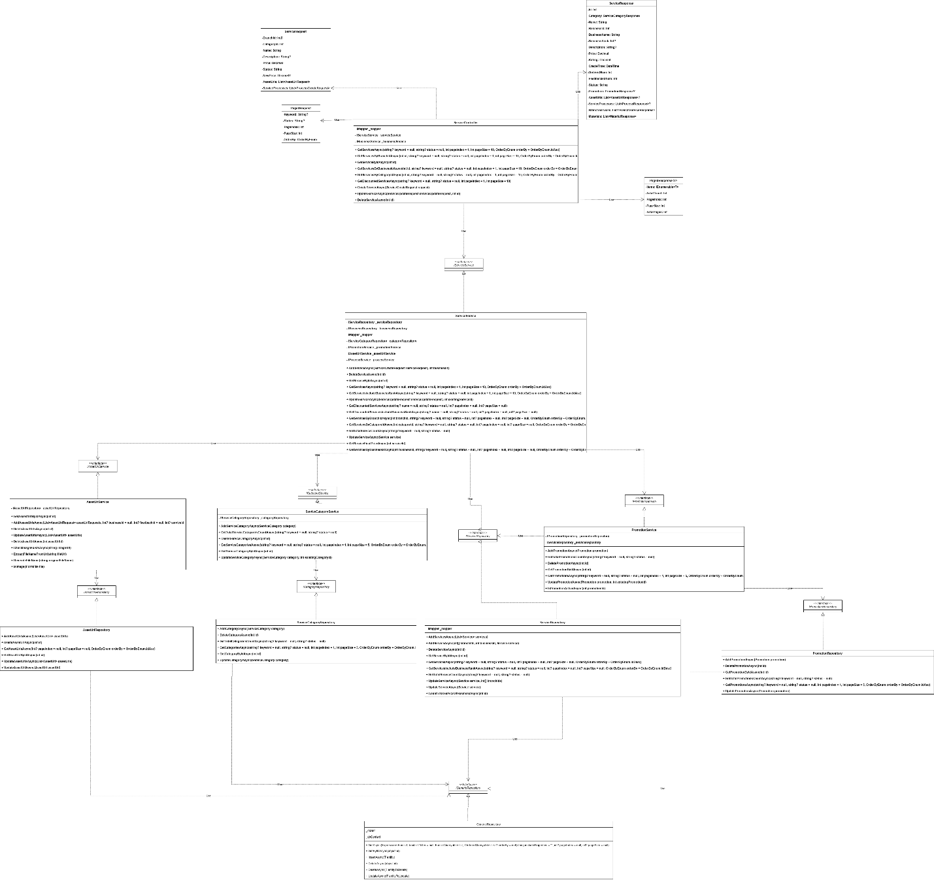

3.1.2 Sequence Diagram

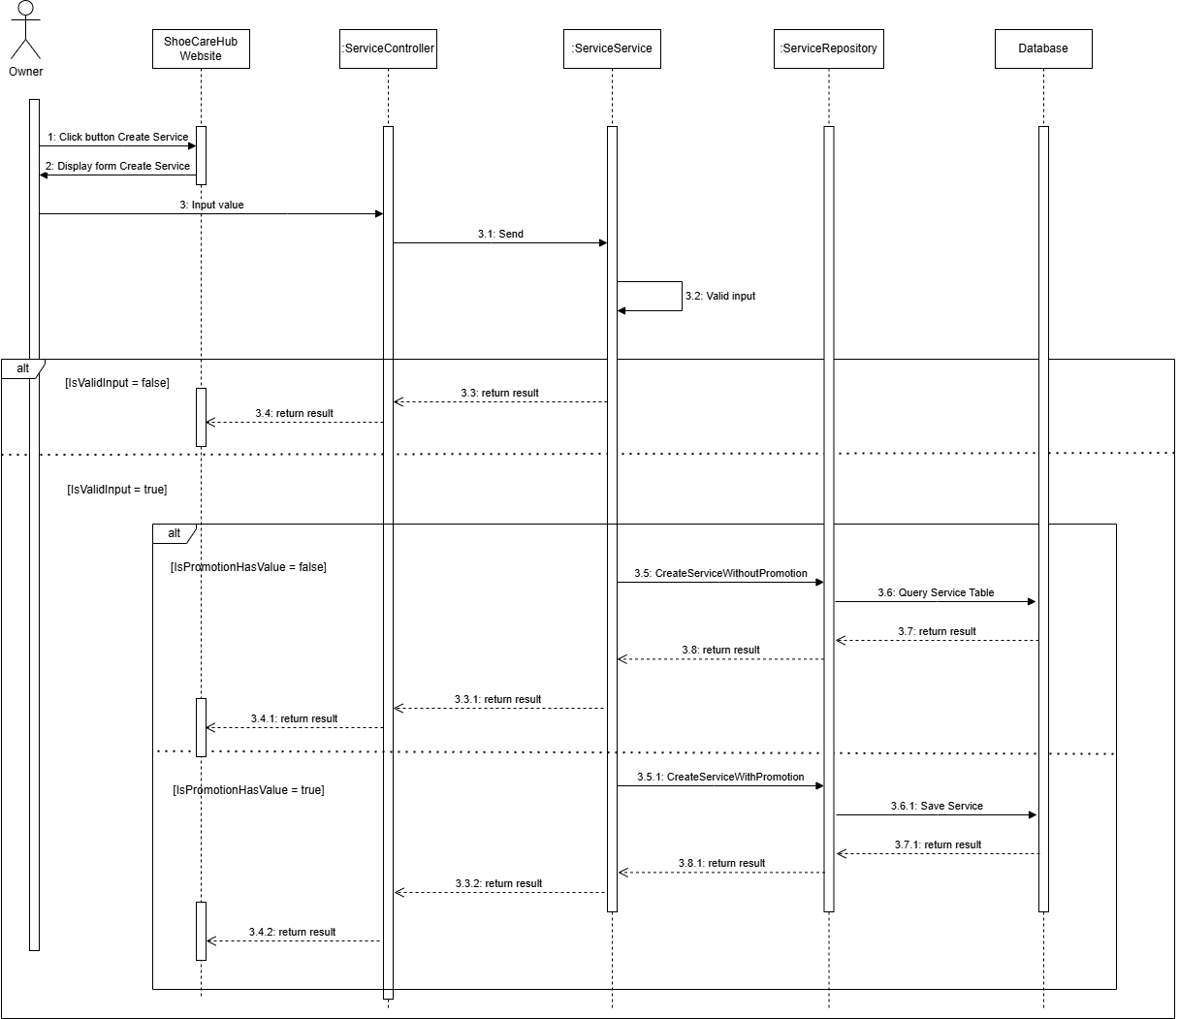

3.1.3 Activity Diagram

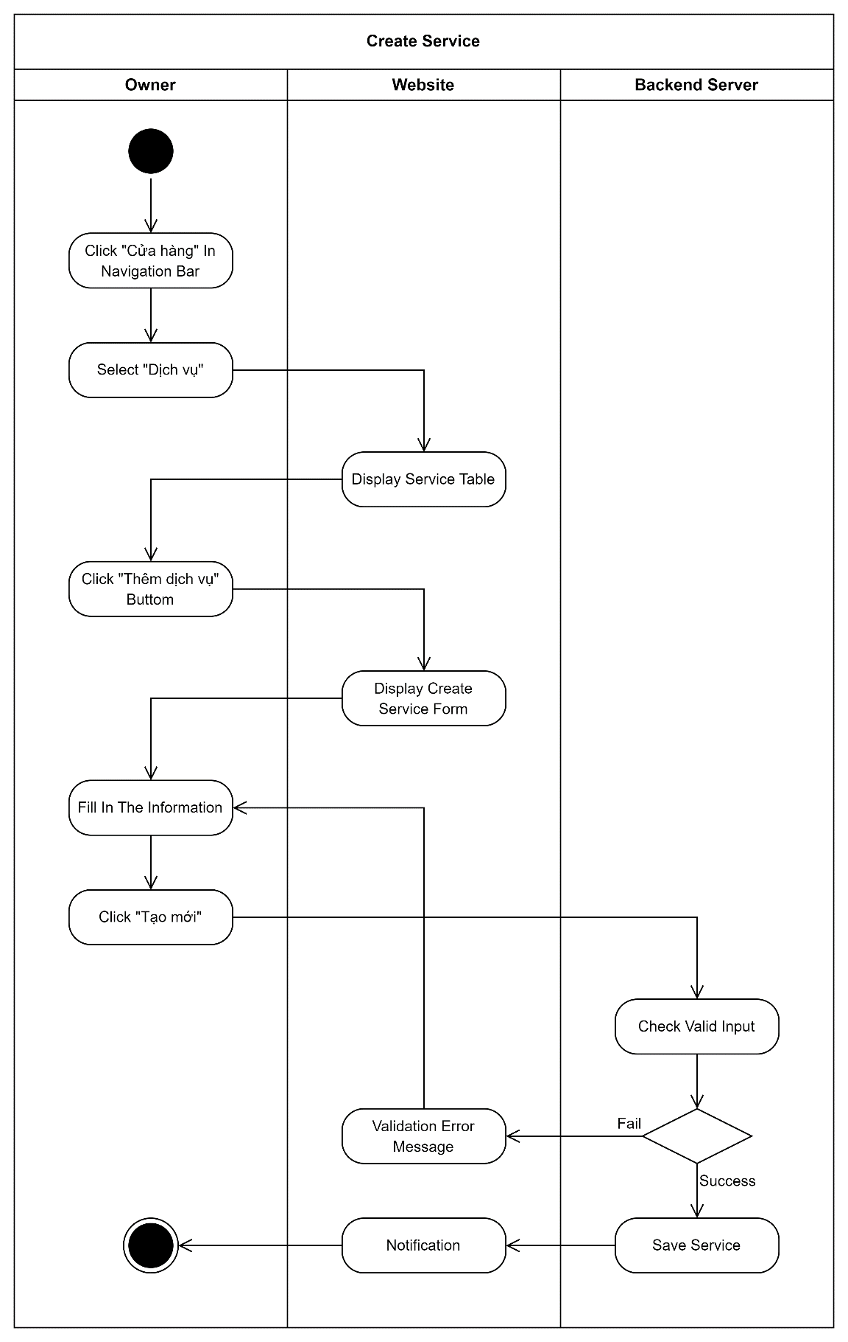

3.2 Add To Cart

3.2.1 Class Diagram

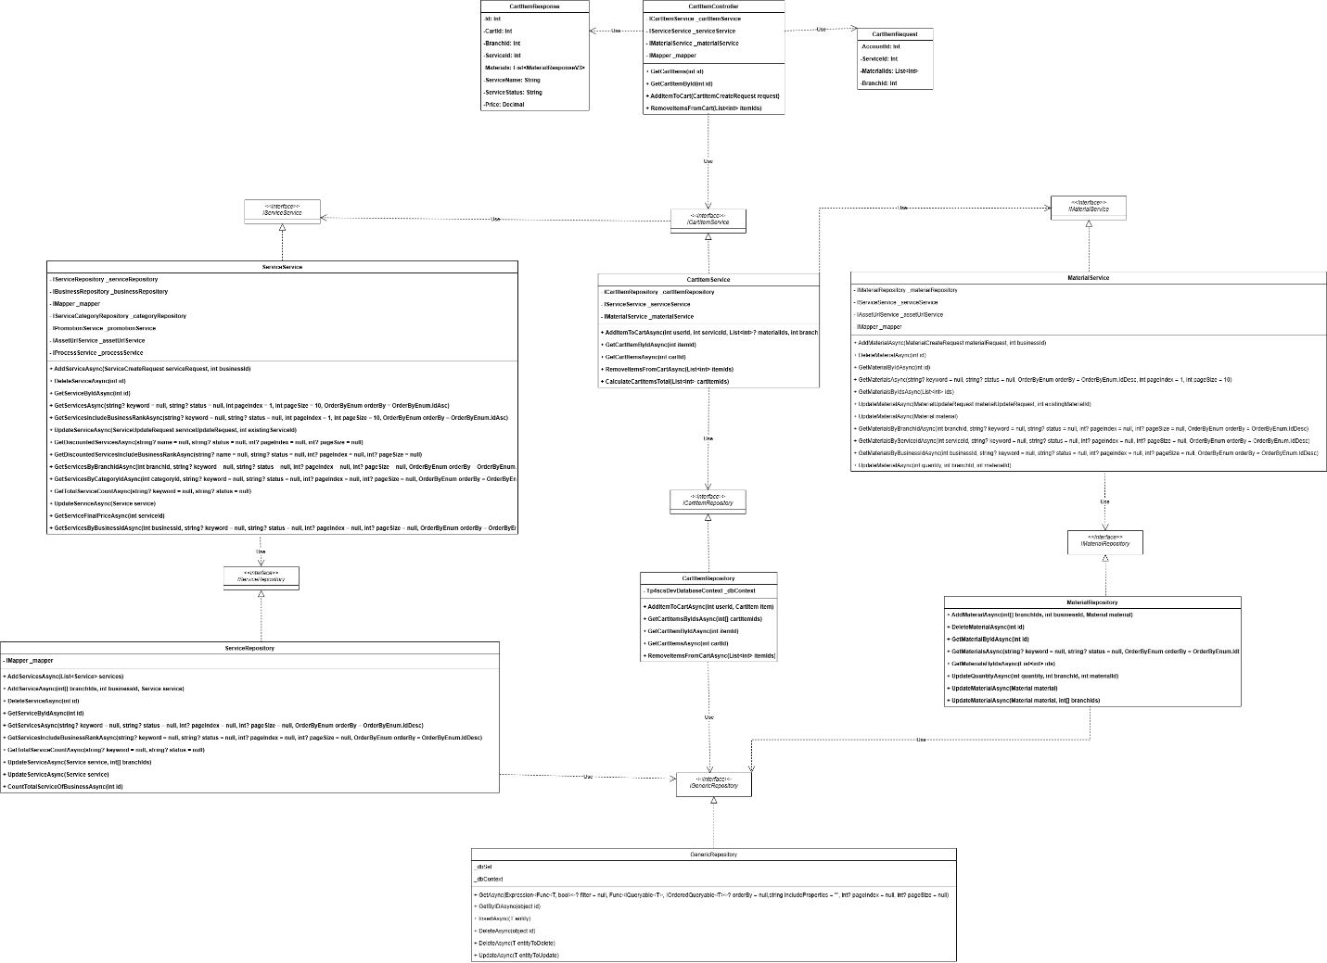

3.2.2 Sequence Diagram
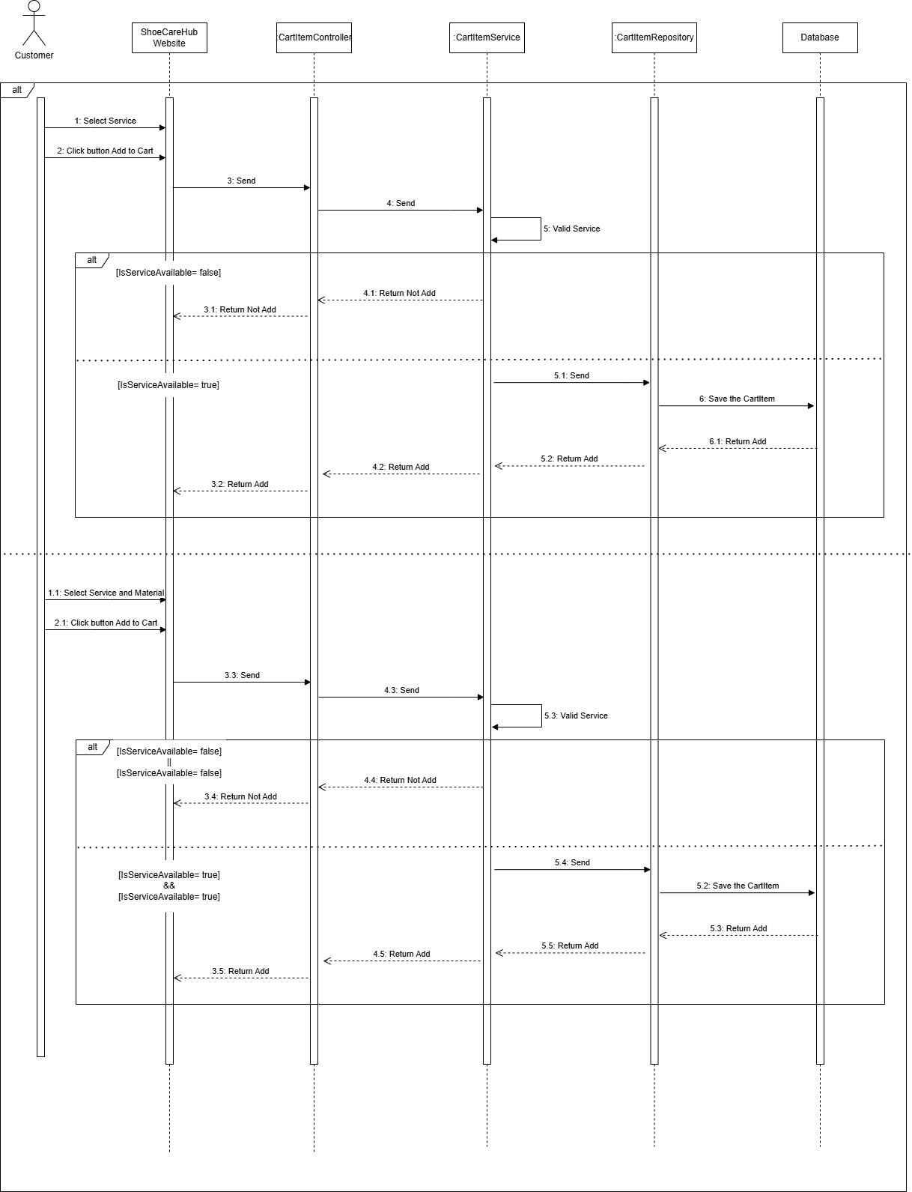

3.2.3 Activity Diagram
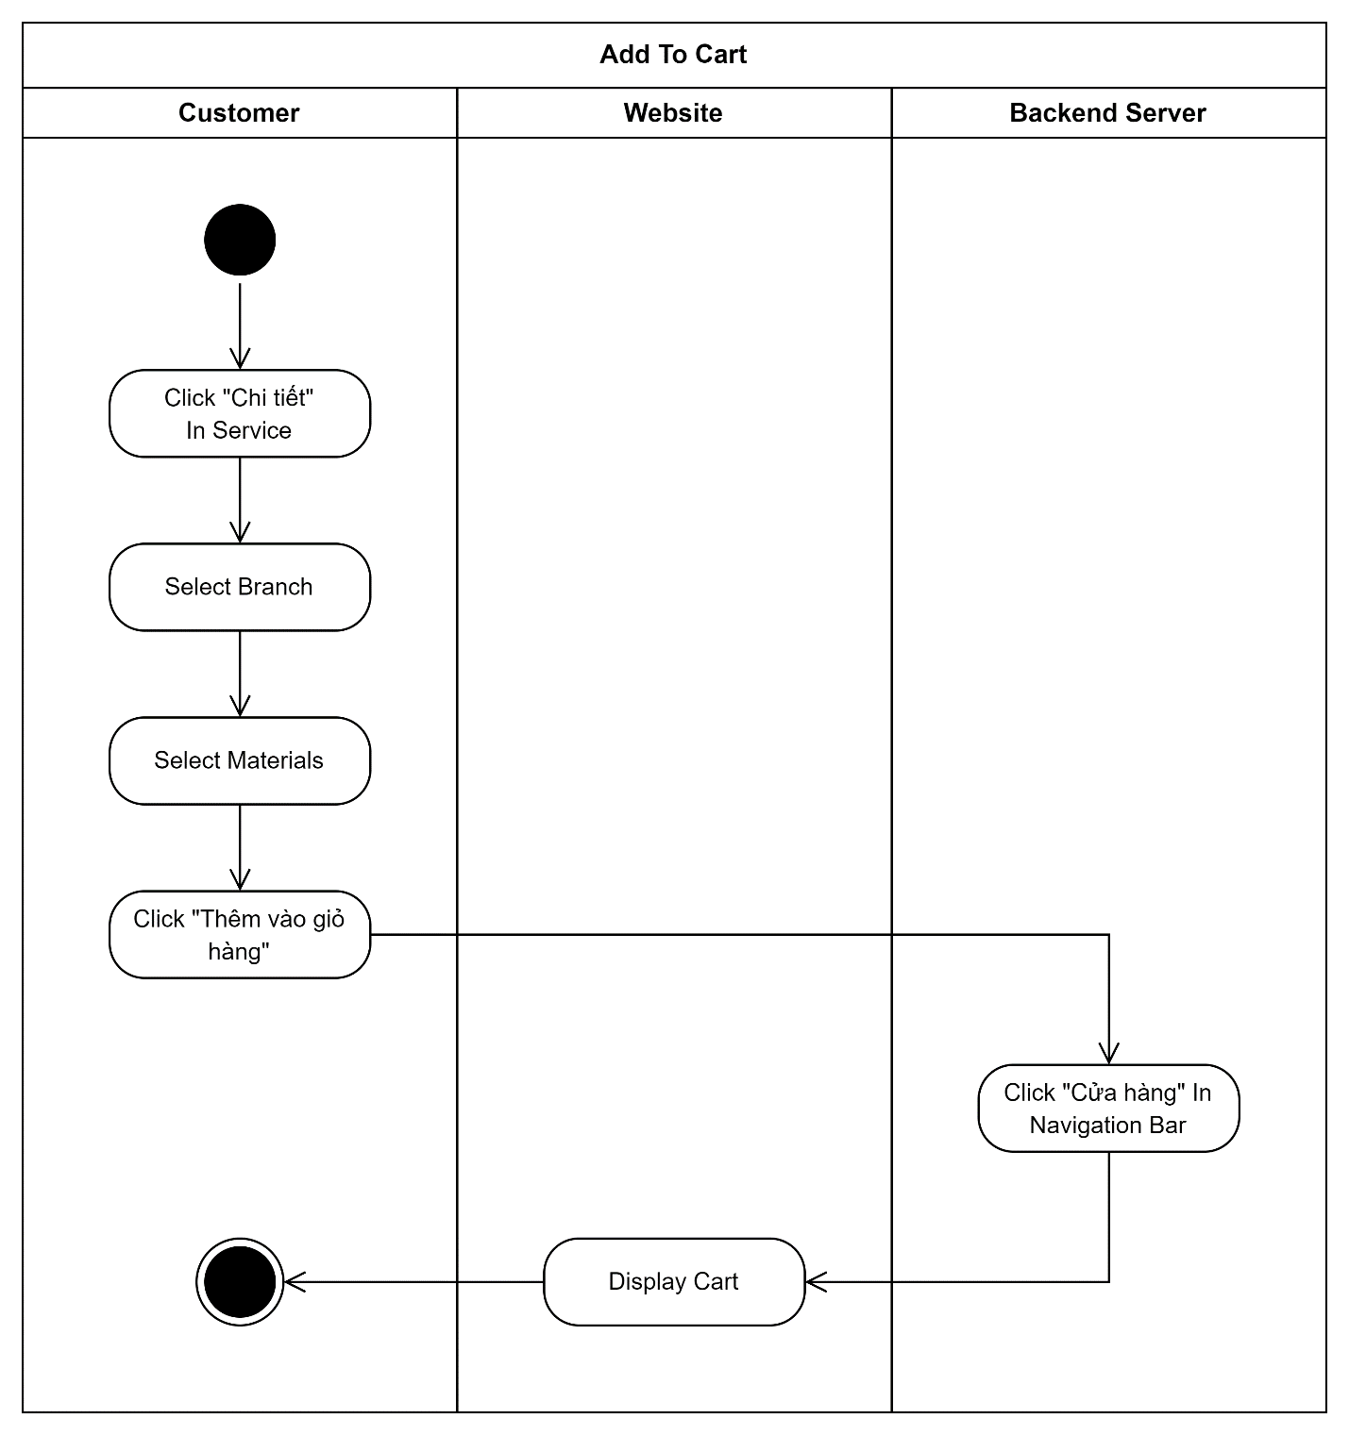

3.3 Create Material

3.3.1 Class Diagram

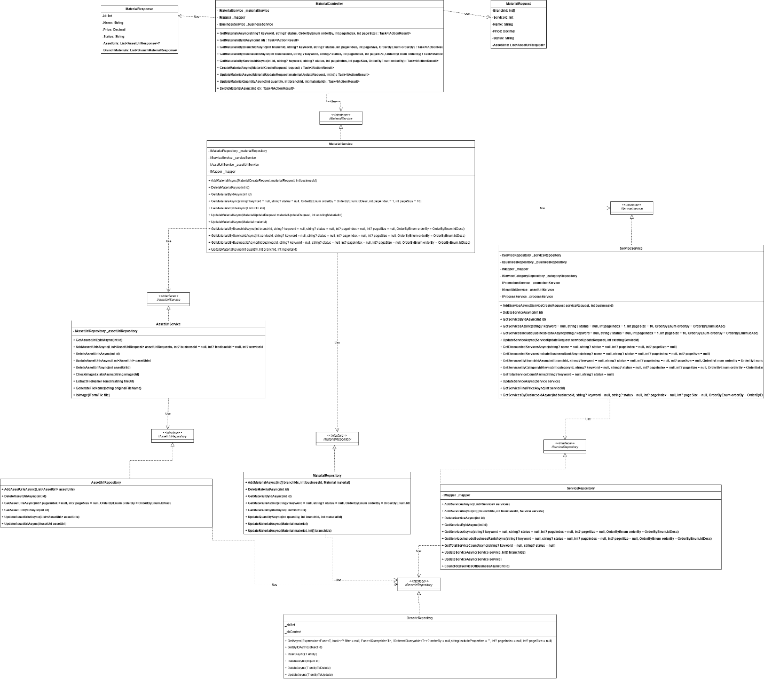

3.3.2 Sequence Diagram

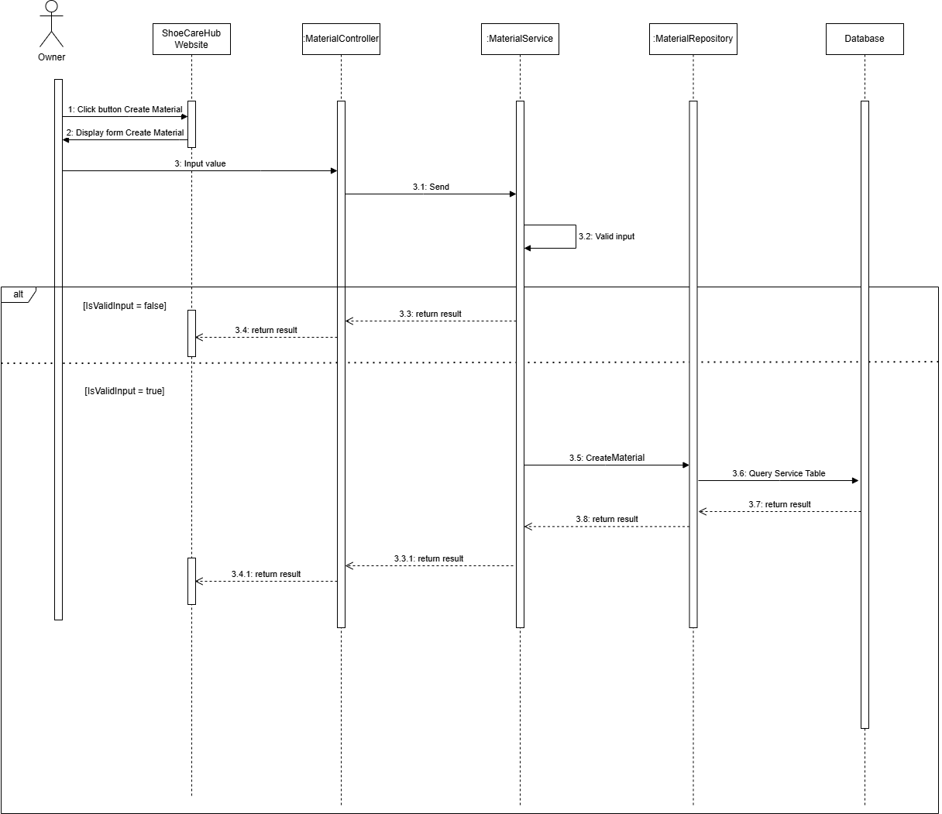

3.3.3 Activity Diagram
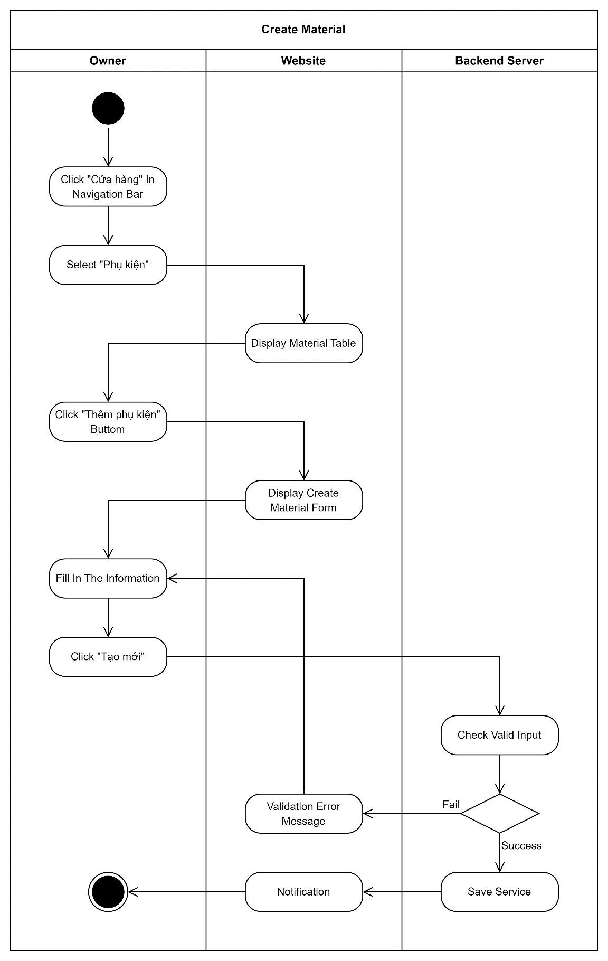

3.4 Check out

3.4.1 Class Diagram

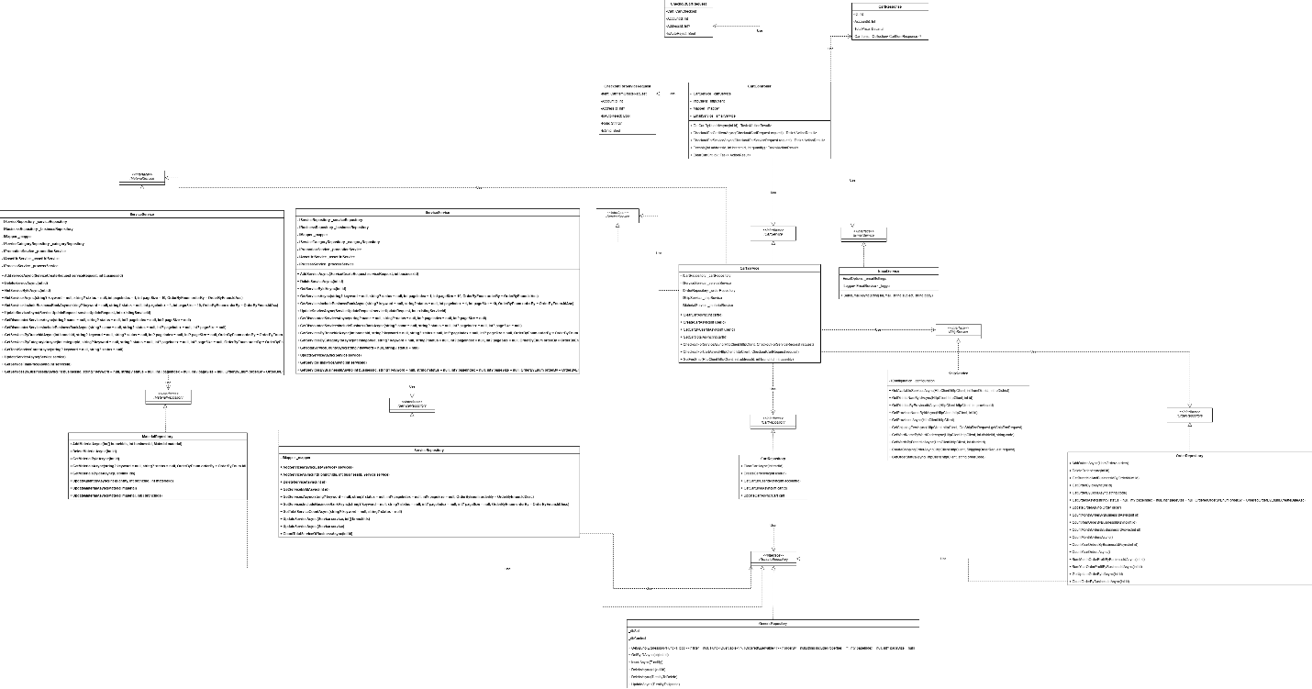

3.4.2 Sequence Diagram
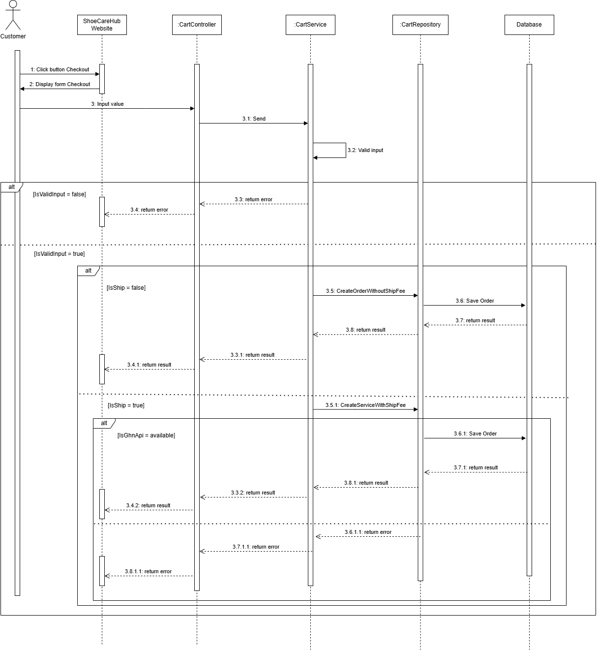

3.4.3 Activity Diagram
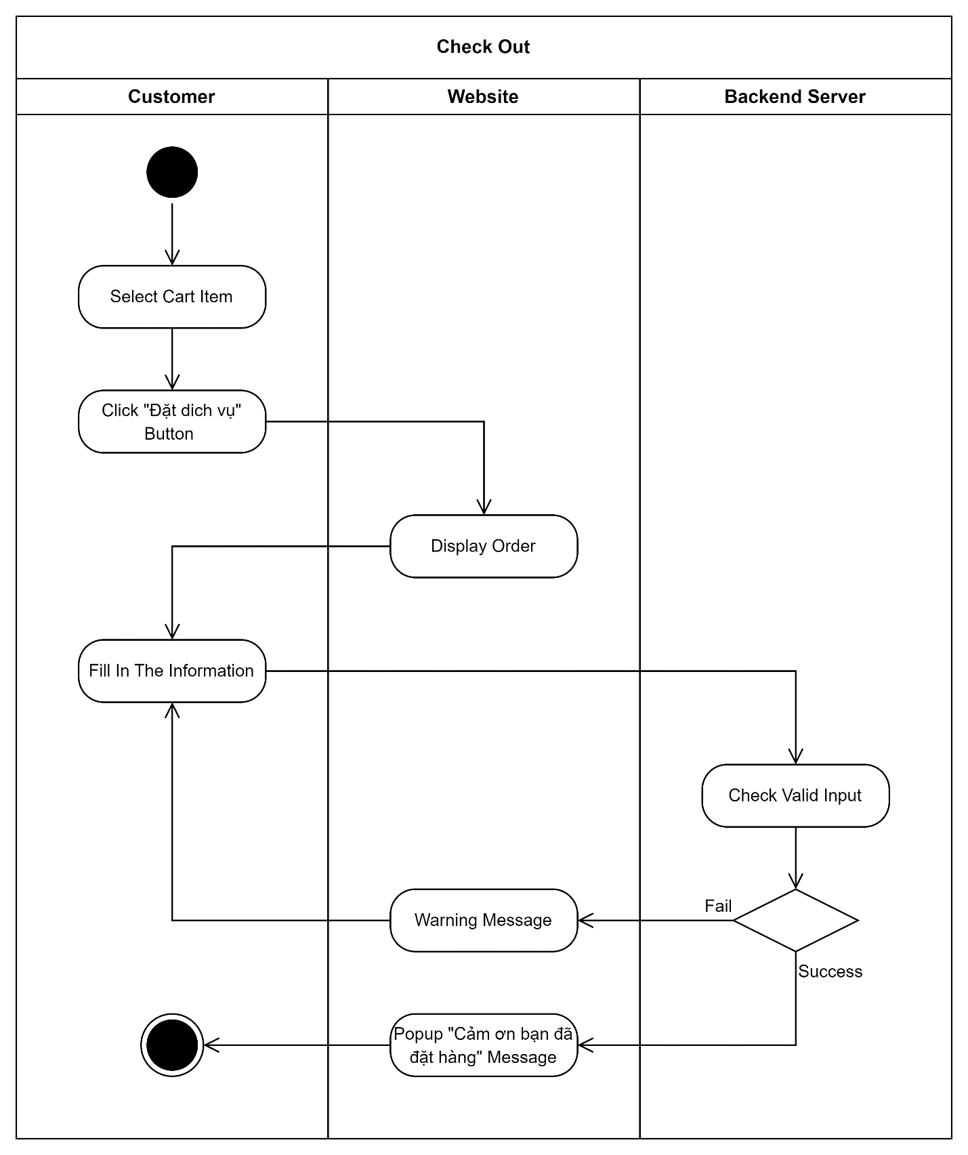

3.5 Create Feedback

3.5.1 Class Diagram

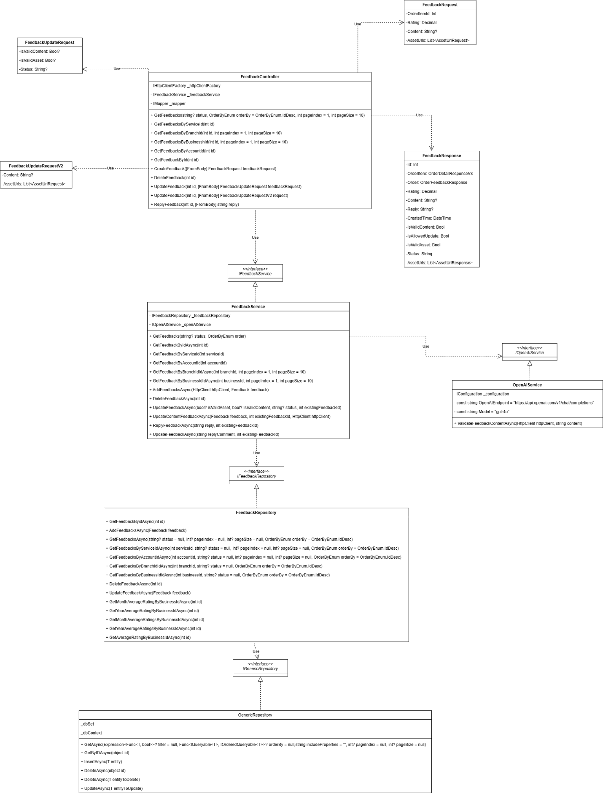

3.5.2 Sequence Diagram

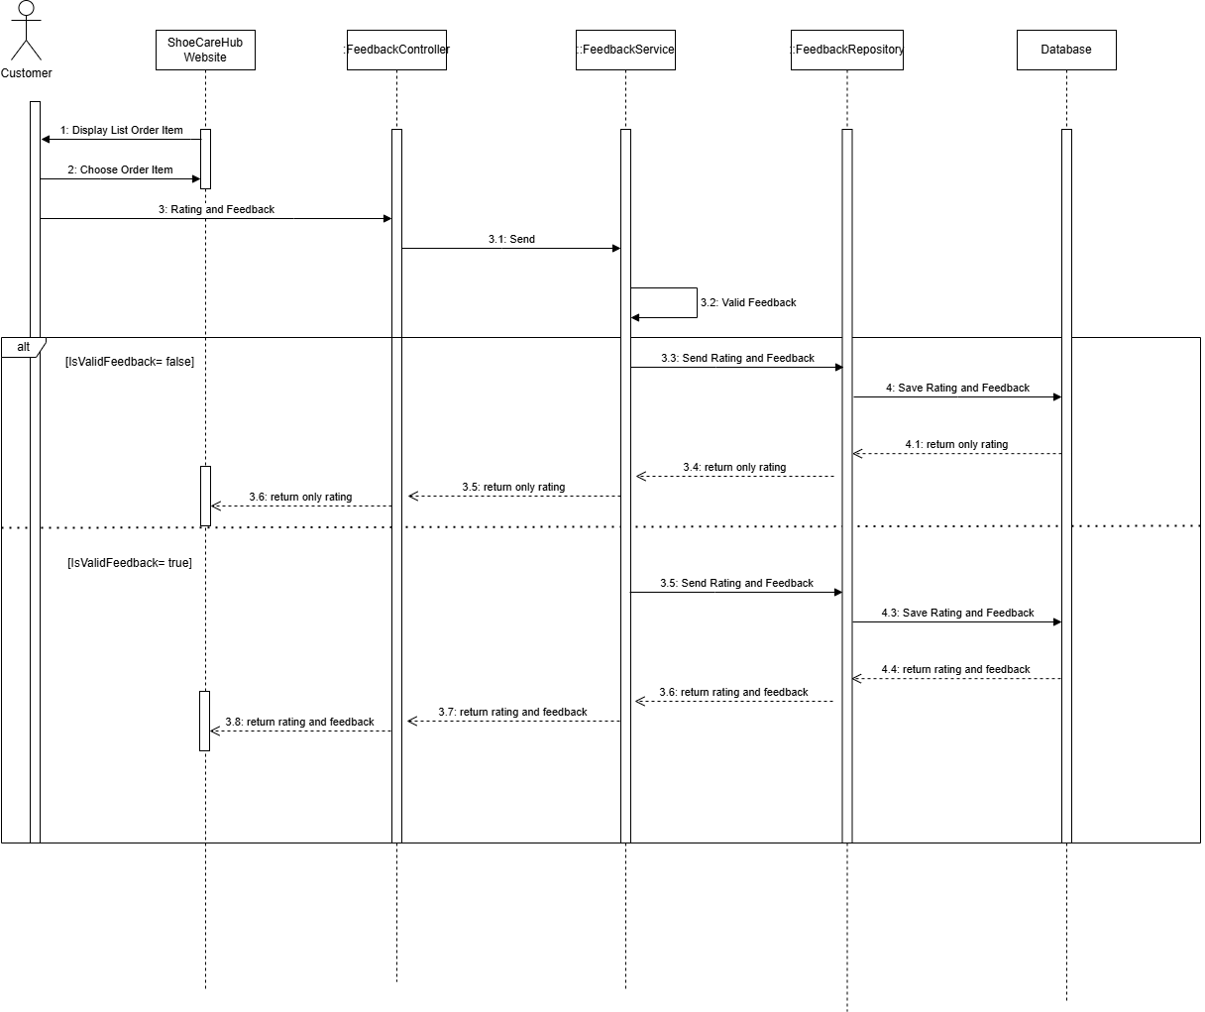

3.5.3 Activity Diagram
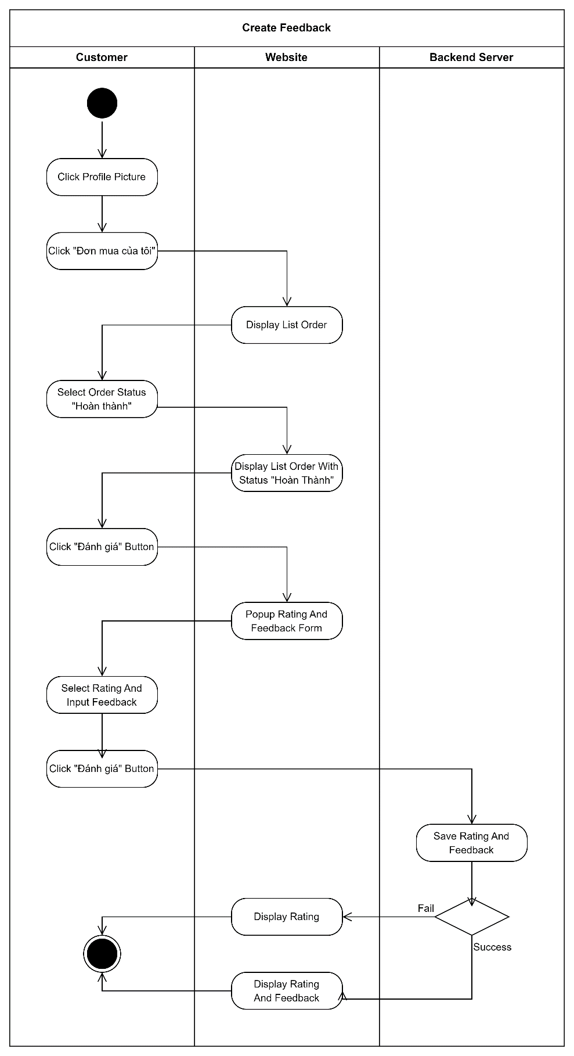

3.6 Register Business

3.6.1 Class Diagram
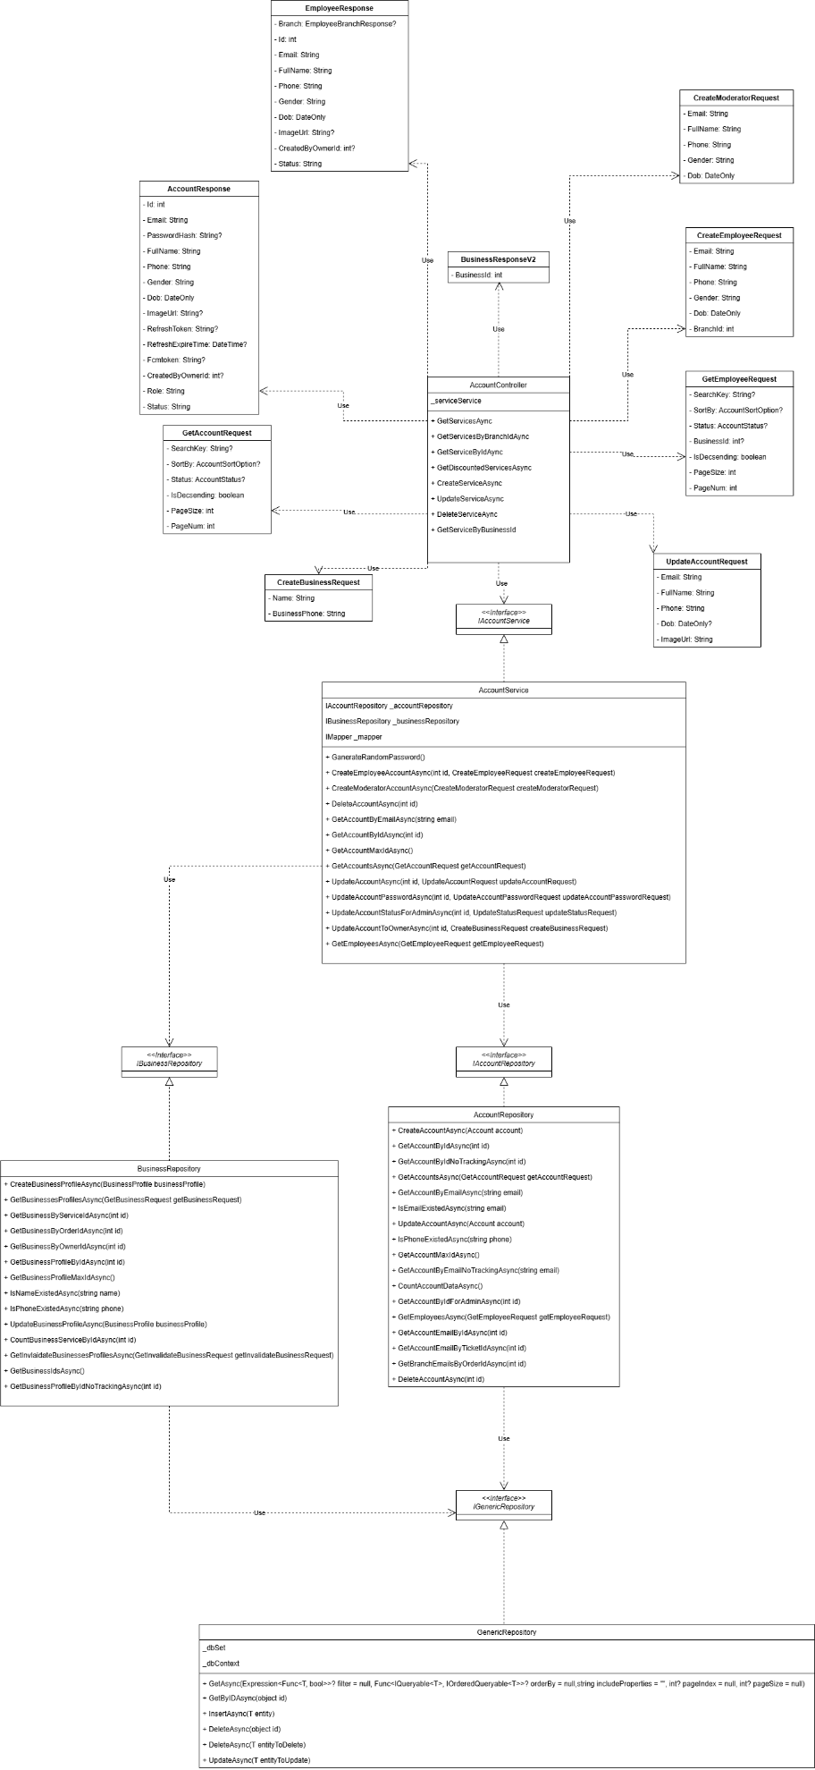

3.6.2 Sequence Diagram

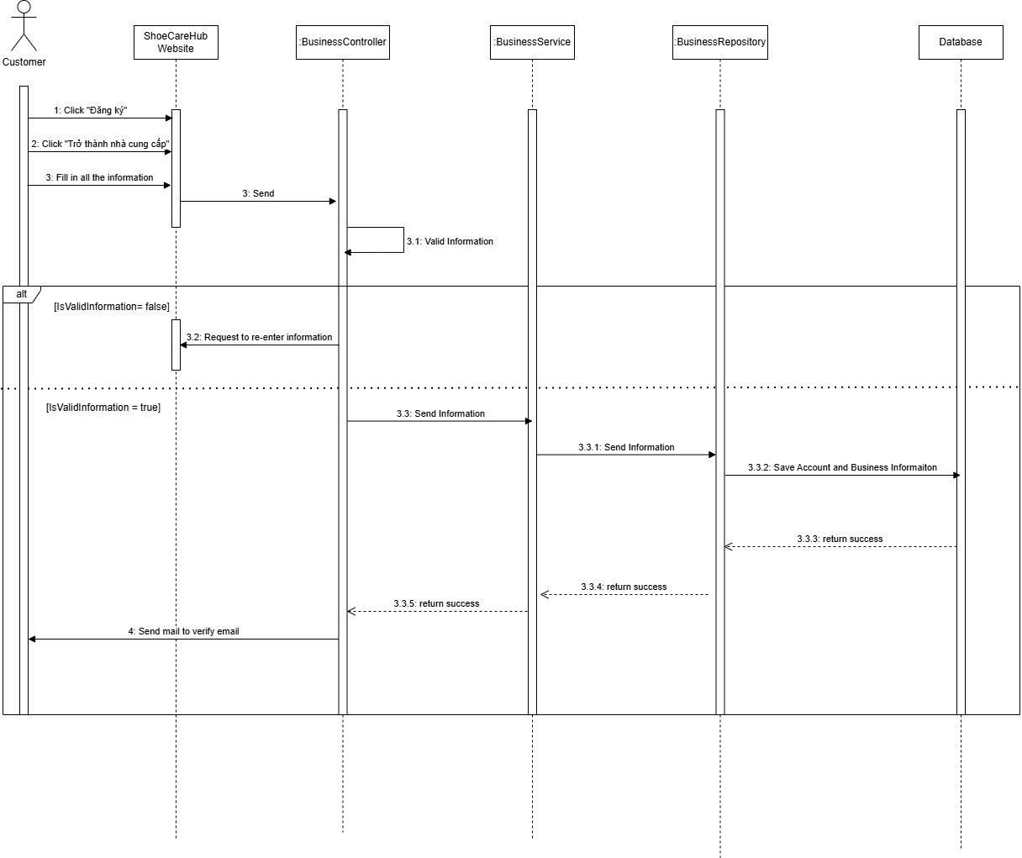

3.6.3 Activity Diagram
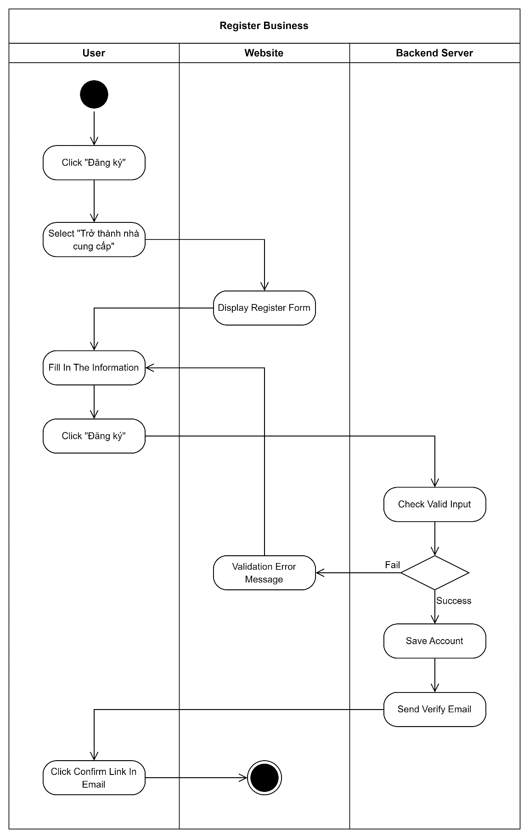

3.7 Create Ticket

3.7.1 Class Diagram

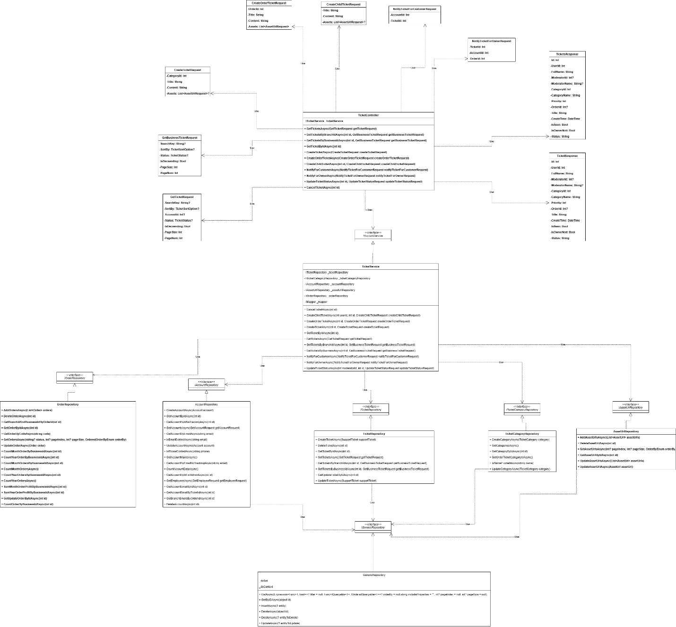

3.7.2 Sequence Diagram

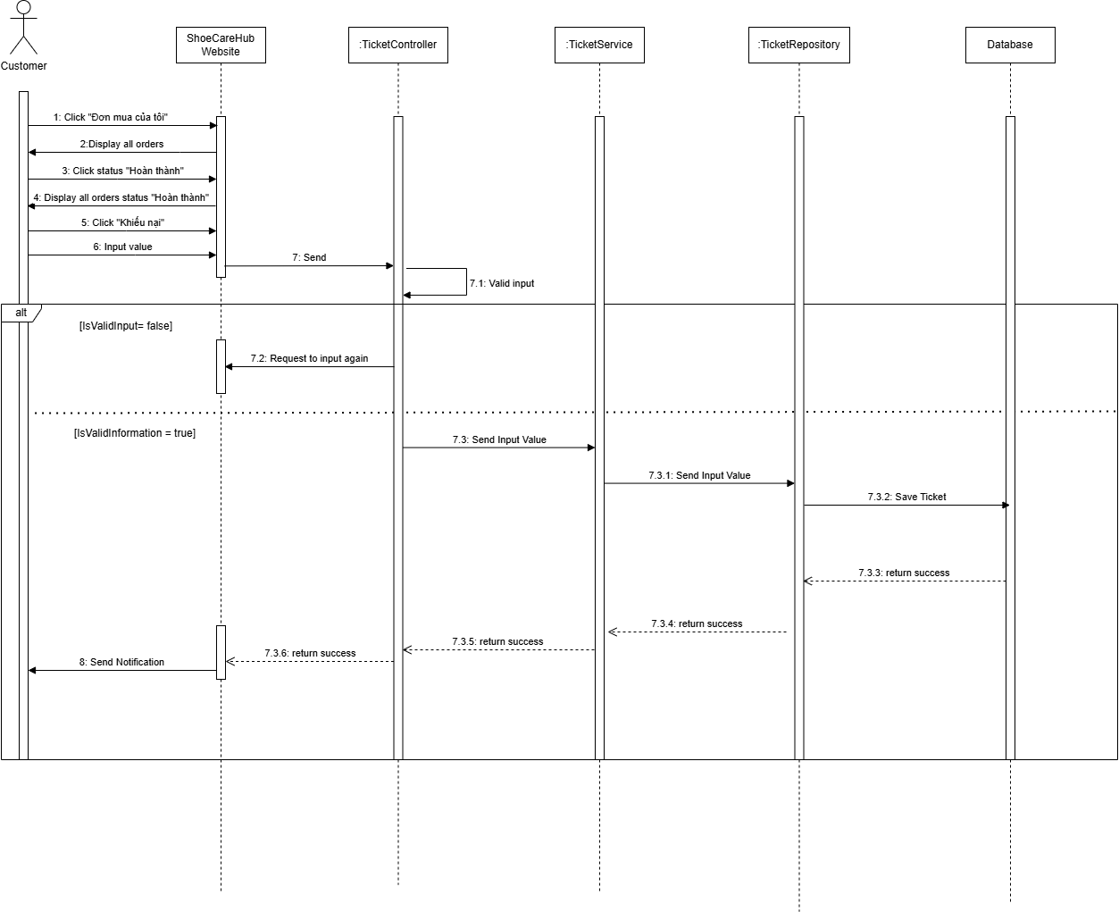

3.7.3 Activity Diagram
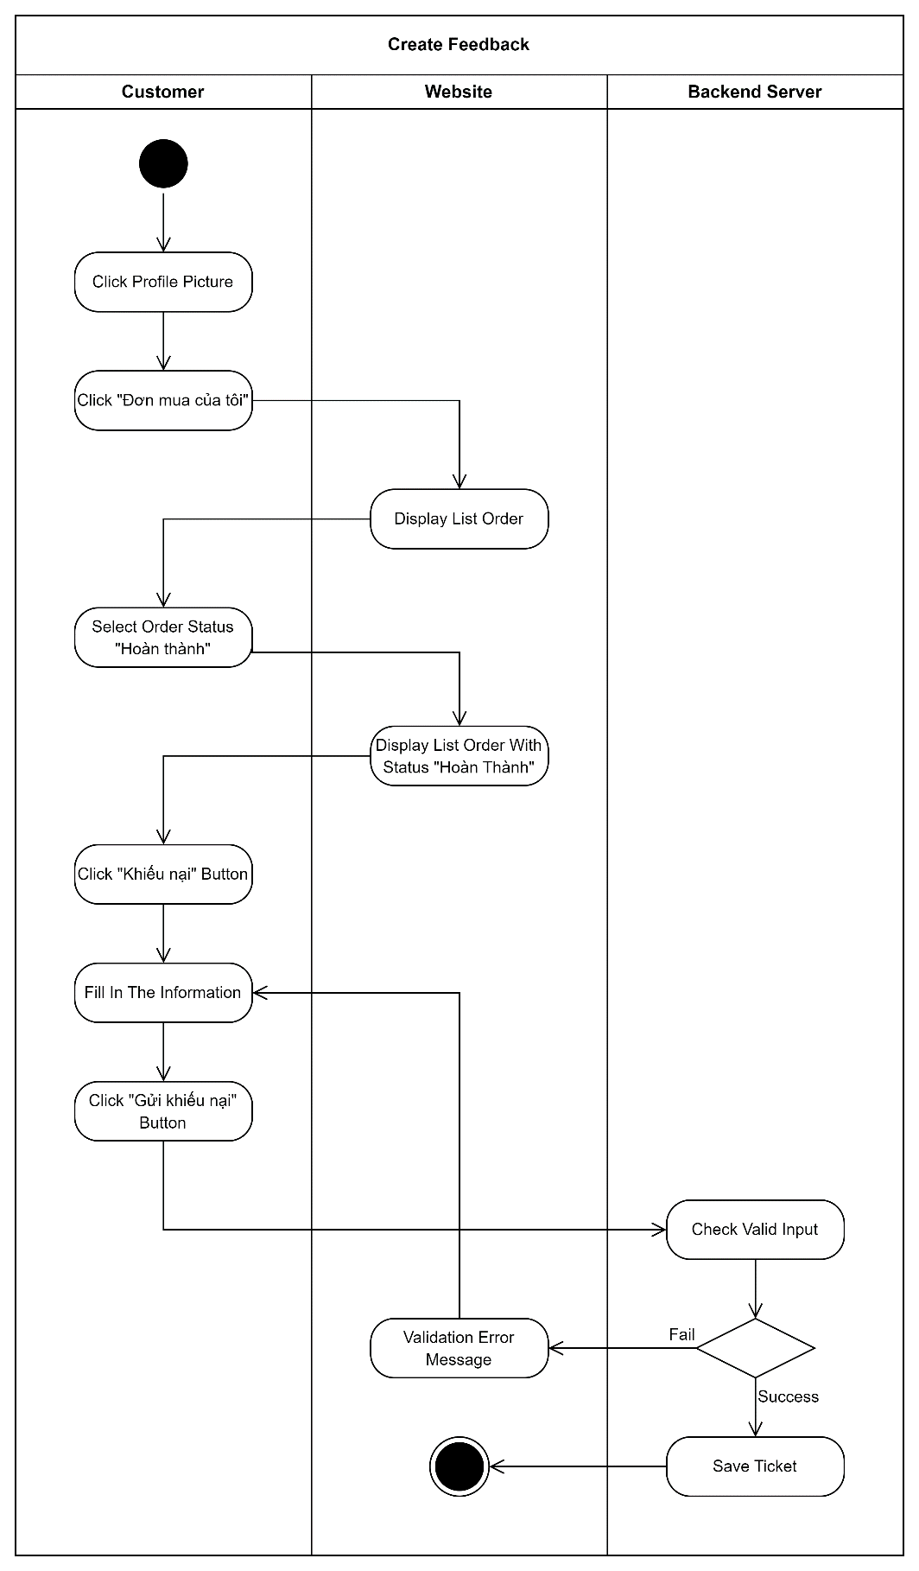

3.8 State Diagram

3.8.1 Business State Diagram
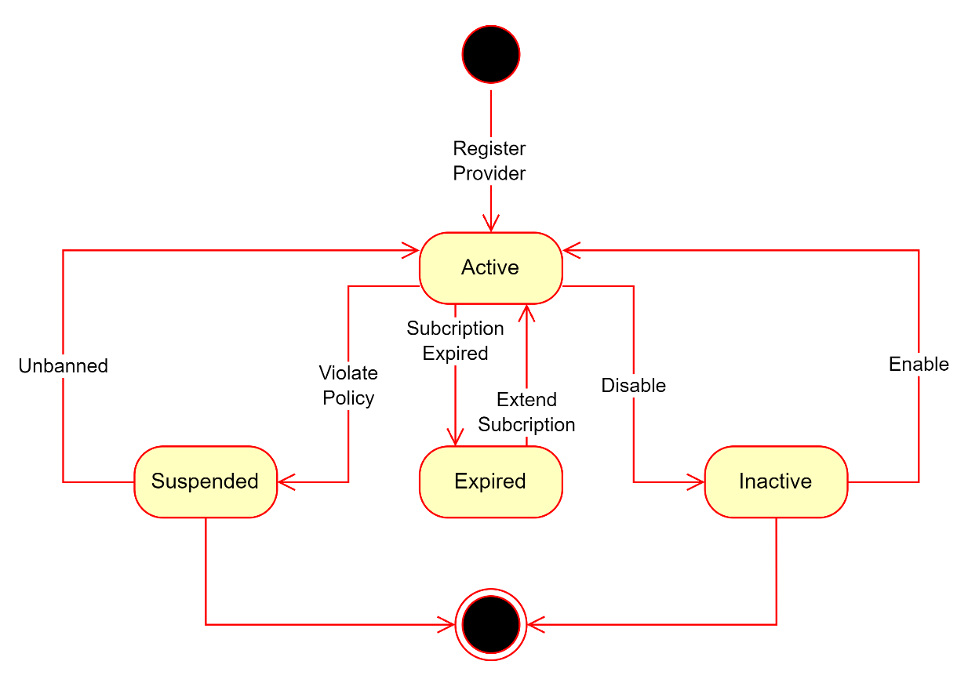

3.8.2 Branch State Diagram
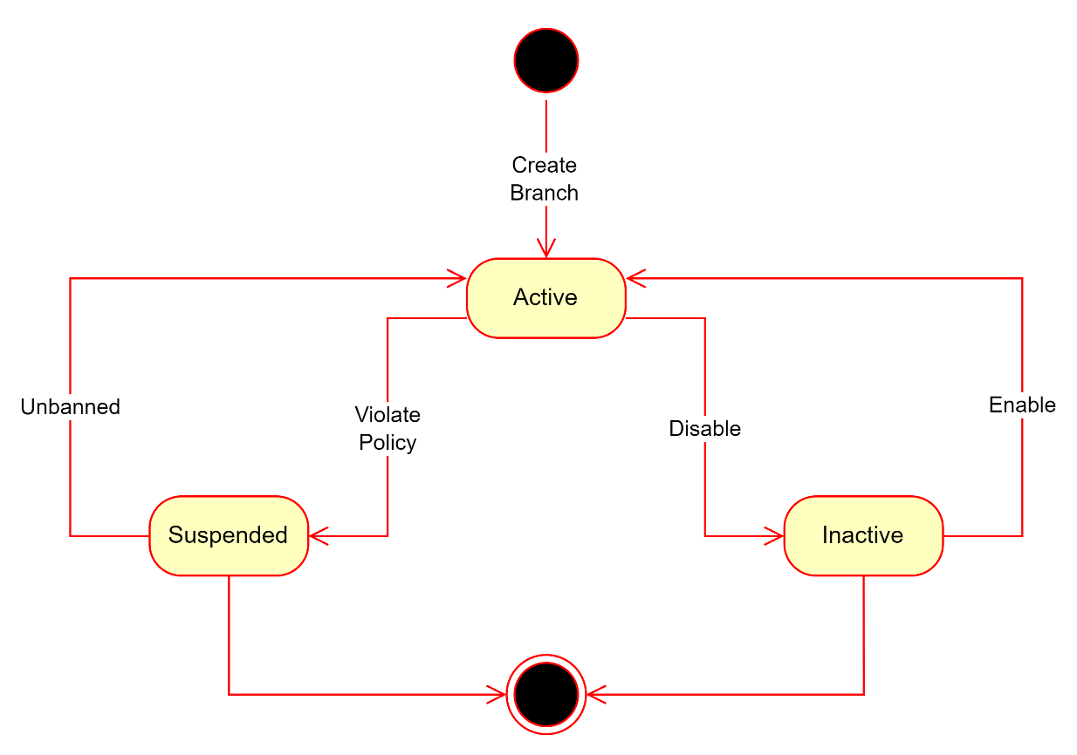

3.8.3 Order State Diagram
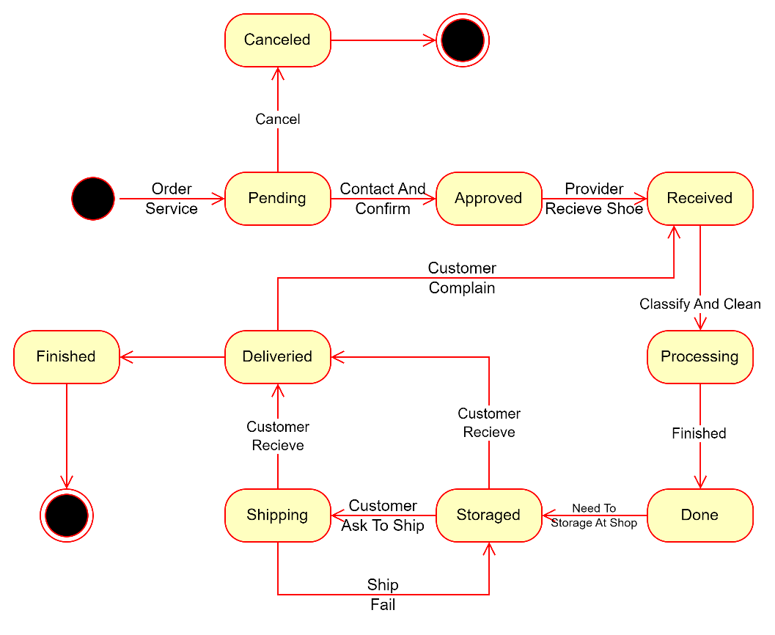

3.8.4 Promotion State Diagram
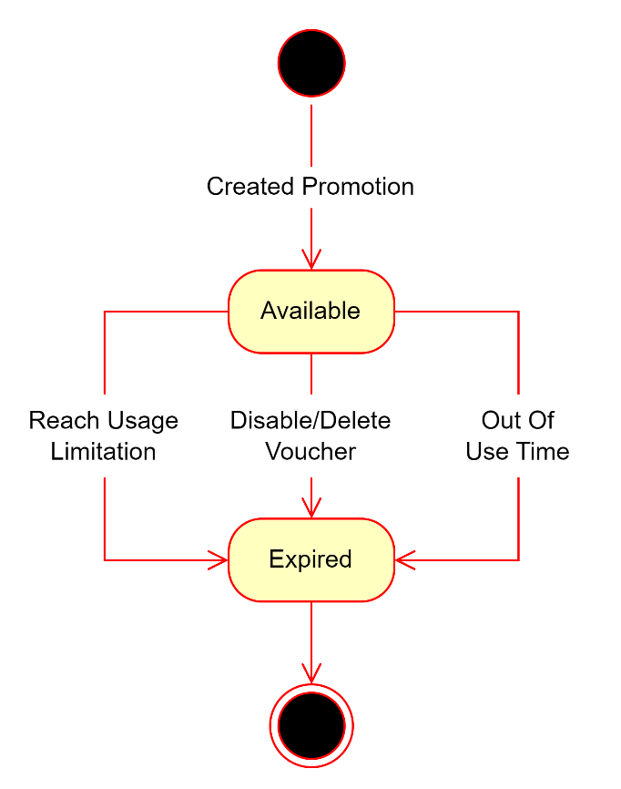

3.8.5 Service State Diagram
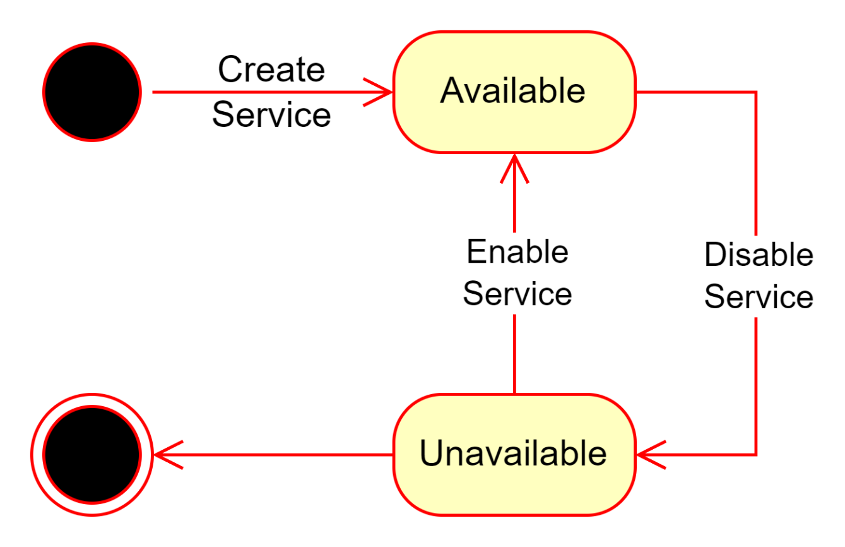

3.8.6 Support Ticket State Diagram
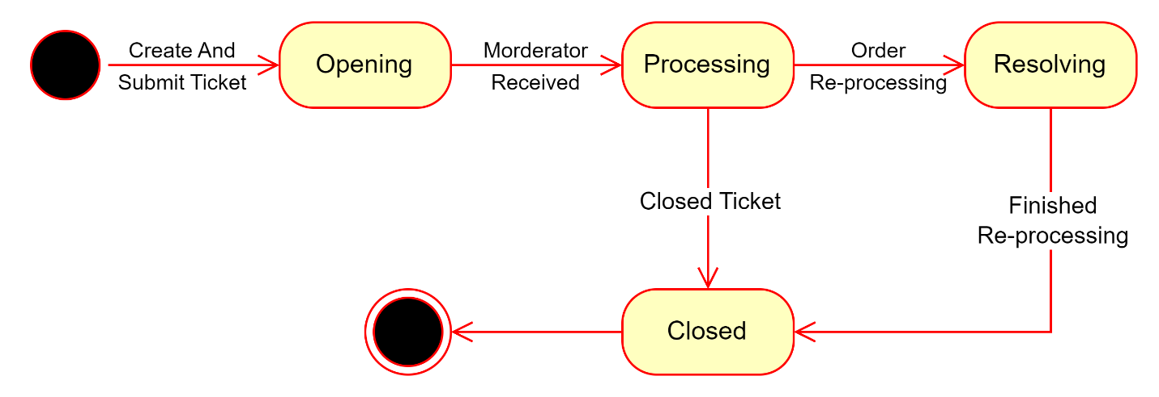

3.8.7 Transaction State Diagram
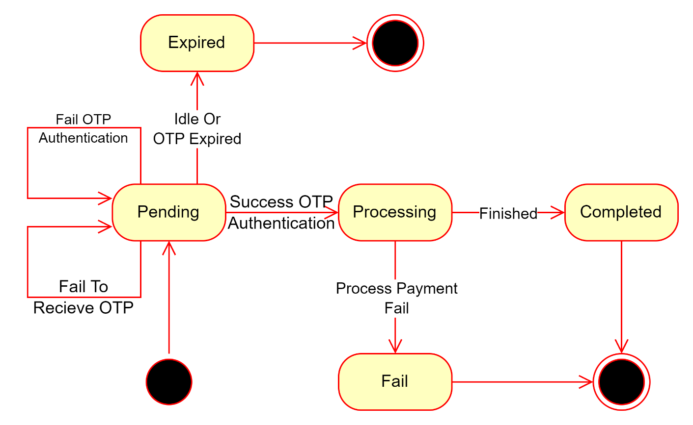

3.8.8 Account State Diagram
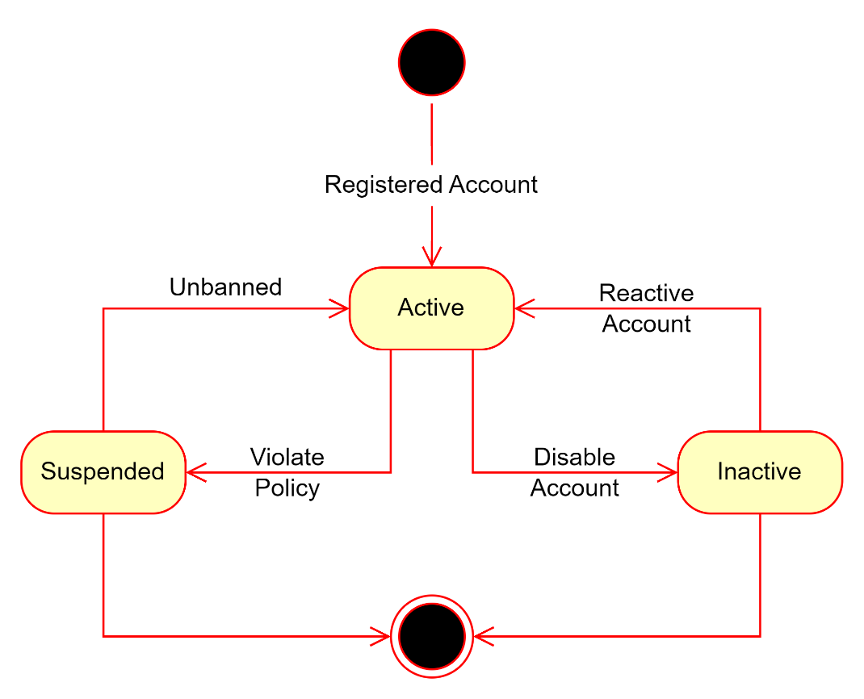

4. Ranking Algorithm

4.1 Theory and Practice:
The algorithm analyzes business raking score from the rating and sale volume from the previous month. It sorts all the raking score of each business in the platform, this helps the business to known if their business is in the top or not.

4.2 Calculation Formula:
_ Using Penalty Factor: a value added to the ranking formula to reduce the overwhelming influence of one factor, ensuring a balance among other factors.
_ Algorithm: Sore = Rating * (1 + 0.3 * $\sqrt{Sale Volume}$)
- Rating: average month feedback rating of business.
- 0.3: penalty factor
- Sale Volume: total finished order in month of business.

